
National University of Computer & Emerging Sciences, Karachi
Spring-2021 CS-Department
Final Exam
13th of January 2022, 9:00 am – 12:00 pm
Course Code: CS3005 | Course Name: Theory of Automata
Instructor Name: Mr. Musawar
Student Roll No:
Instructions:
- Return the question paper.
- Attempting of the question in the given order is highly encouraged.
- Read each question completely before answering it. There are 5 questions on 7 pages.
- In case of any ambiguity, you may make assumption. But your assumption should not contradict any statement in the question paper.

Time: 180 minutes. Max Point: 100
Question 1: Miscellaneous MCQs (20 Points)
Write the solutions of MCQs on your answer sheet. Answers of MCQs on question paper would not be accepted.
1. A push down automaton employs ________ data structure.
a) Queue
b) Linked List
c) Hash Table
d) Stack
2. A string is accepted by a PDA when
a) Stack is not empty
b) Acceptance state
c) All of the mentioned
d) None of the mentioned
3. State true or false:
Statement: Every context free grammar can be transformed into an equivalent non deterministic push down automata.
a) true
b) false

4. Which of the following option resembles the given PDA? (# is stack symbol).
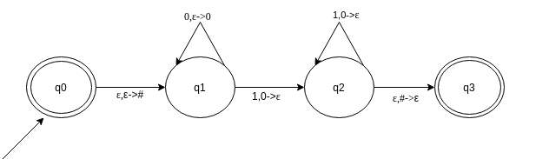
Find the option which resembles the given PDA
a) {0n1n|n>=0}
b) {0n12n|n>=0}
c) {02n1n|n>=0}
d) None of the mentioned
5. Which of the following are the actions that operates on stack top?
a) Pushing
b) Popping
c) Replacing
d) All of the mentioned
6. Which of the following statement is false?
a) Context free language is the subset of context sensitive language
b) Regular language is the subset of context sensitive language
c) Recursively enumerable language is the super set of regular language
d) Context sensitive language is a subset of context free language
7. For S->0S1|e for ∑={0,1}*, which of the following is wrong for the language produced?
a) Non regular language
b) 0n1n | n>=0
c) 0n1n | n>=1
d) None of the mentioned

8. Are ambiguous grammar context free?
a) Yes
b) No
9. Given Grammar: S->A, A->aA, A->e, B->bA
Which among the following productions are Useless productions?
a) S->A
b) A->aA
c) A->e
d) B->bA
10. Given grammar G:
S->aS|A|C
A->a
B->aa
C->aCb
Find the set of variables that can produce strings only with the set of terminals.
a) {C}
b) {A,B}
c) {A,B,S}
d) None of the mentioned
11. A Turing machine operates over:
a) finite memory tape
b) infinite memory tape
c) depends on the algorithm
12. Which of the functions are not performed by the Turing machine after reading a symbol?
a) writes the symbol
b) moves the tape one cell left/right
c) proceeds with next instruction or halts
d) none of the mentioned
13.Which of the following a Turing machine does not consist of?
a) input tape
b) head
c) state register
d) none of the mentioned
14. Which of the following options resemble with the given Turing Machine?
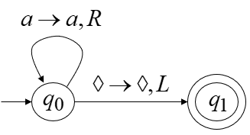
- a*
- a+
- λ
- none
15. Turing Machine accepts following languages
a) Recursively Enumerable
b) Regular Languages
c) Context Free Languages
d) Context Sensitive Languages
c) All of these
d) None of these
16. Number of states require to accept string ends with 10 having alphabet {0,1}.
a) 3
b) 2
c) 1
d) can’t be represented.

17. Regular expression for all strings starts with ab and ends with bba is.
a) aba*b*bba
b) ab(ab)*bba
c) ab(a+b) *bba
d) All of the mentioned
18. The basic limitation of finite automata is that
a) It can’t remember arbitrary large amount of information.
b) It sometimes recognizes grammar that are not regular.
c) It sometimes fails to recognize regular grammar.
d) All of the mentioned
19. Which of the following does the given NFA represent?
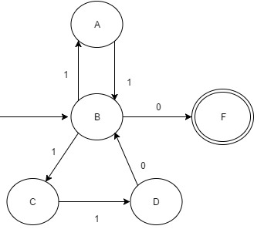
a) {11, 101} * {01}
b) {110, 01} * {11}
c) {11, 110} * {0}
d) {00, 110} * {1}
20. If L is a regular language, complement and reverse of language both will be:
a) Accepted by NFA
b) Rejected by NFA
c) One of them will be accepted

Question 2: (Regular Languages) (8+8+2+2 Points)
- Perform the union of the following DFAs.
- Perform Concatenation of following DFAs.
- Identify the languages of the following DFAs.
- Write down the regular Expressions of the following DFAs.
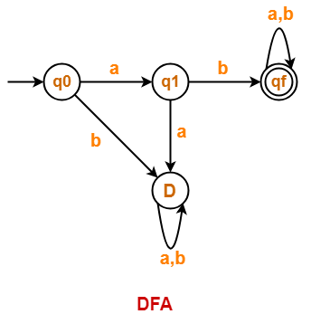 | 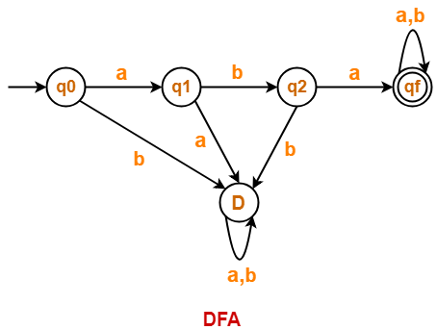
Question 3: (PDA) (5+5+5+5 Points)
- Design a PDA for even-even language.
- Show the stack operations for the word abababab on the PDA you have designed.
- Design a PDA for following language
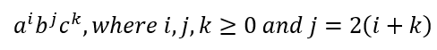
- Design a PDA for following language
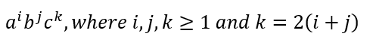

Question 4: (CFG) (5+10+5 Points)
- Write Down the CFG for following languages.
- ab (a+ b) *ab
- Palindrome language over alphabet ∑= {a, b}
- Simplify the following CFG and Convert the resultant CFG into CNF.
S →A|B
A→ 1CA|1DE|null
B→1CB|1DF
C→1CC|1DG|0G
D→1CD|1DH
E→0A
F→0B
H→ 1
G→ Null
- Convert the following CFG into PDA
S→ ABC|AB|AC|C
B→ 0|1
C→AC|B
D→0|1
Question 5: (Turing Machine) (4+4+4+4+4)
- Design the Turing Machine for 011(0+1) *010. Draw the Turing Tape and Show the steps for word 010.
- Draw Chomsky’s Hierarchy and highlight the type languages for which Turing machine can be formed.
- Design a Turing machine for (0+1) * and discuss whether the languages (0+1) ⁺ and (001+111) would be accepted by this Turing machine or not.
- Elucidate the difference between ‘accept and halt’ and ‘halt and reject’ in Turing machine.
- Is it considerable to have a self-loop on final state of the Turing machine? Justify?

